EDWARD KUUBERME NAAPONG’S
MALNUTRITION ALBUM
OBSERVATIONS IN THE UPPER WEST REGION, GHANA.

The negative impact of Low education, gender imbalance and poor support for home base and subsistence agriculture.

SUPPORTING PEOPLE ATTAIN THEIR GOAL IS
HAPPINESS

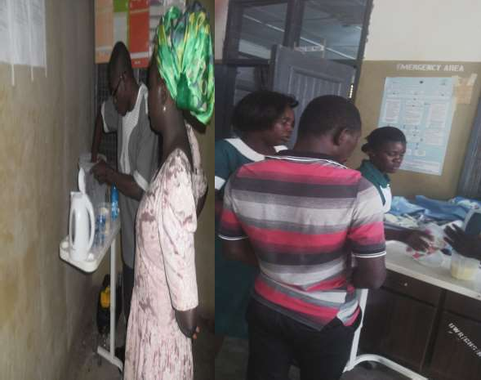
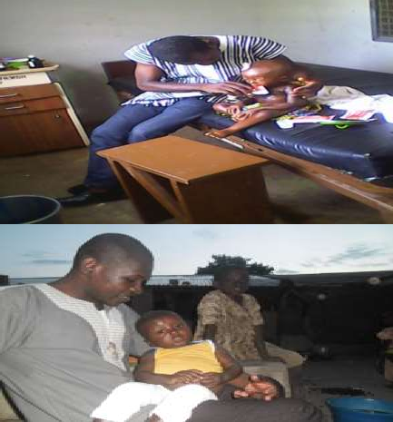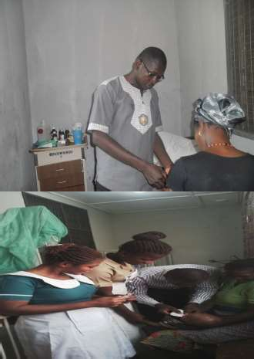Edward preparing and demonstrating feeds to Nurses .
Edward Feeding malnourished children on admission

APPROPRIATE FEED PREPARATION AND DICISSION TAKING ARE KEY TO MALNUTRITION MANAGEMENT.

NUTRITION OFFICER AND SENIOR NURSE
MONITORING FEED PREPARATION BY JUNIOR STAFF
NUTRITION OFFICER RECEIVING SUGGESTIONS FROM
NURSES ON HOW TO IMPROVE CMAM CARE-IPC

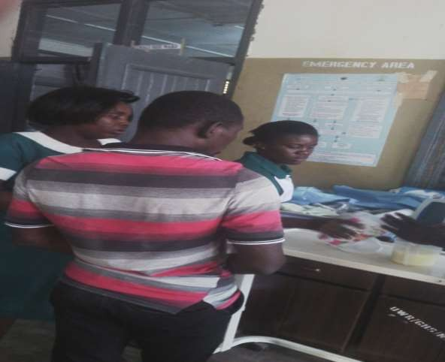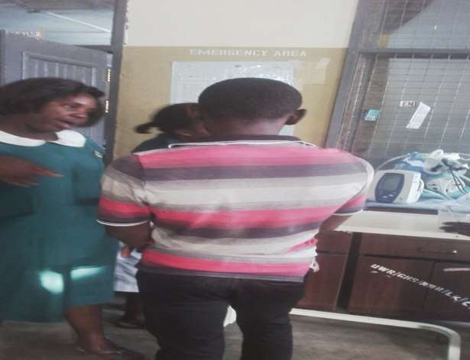

WITH YOU I AM HAPPY WITH GOOD HEALTH.
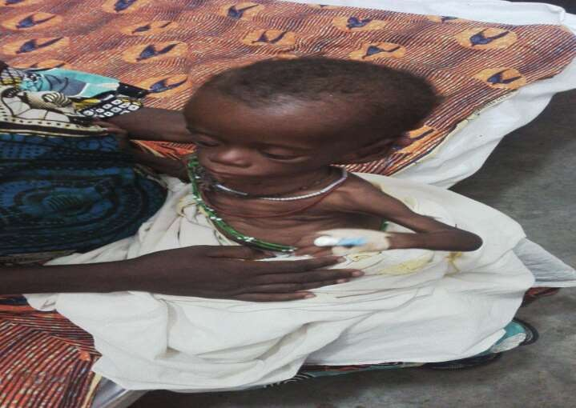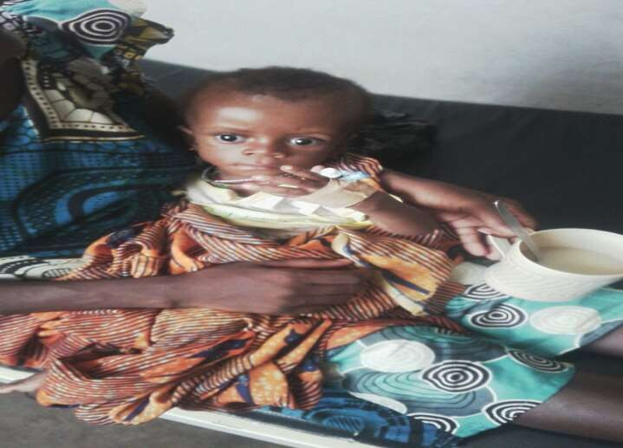BEFORE TREATMENT-IPC AFTER TREATMENT-IPC

Malnourished children need more attention during care than normal
unhealthy child
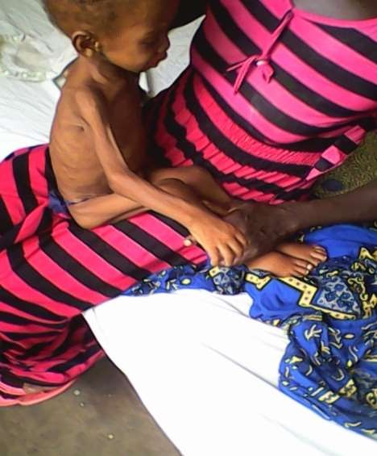
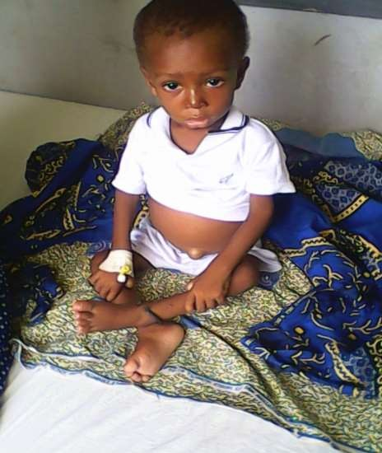Before treatment After treatment-ipc
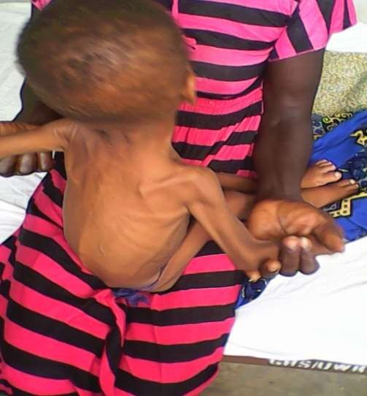

Every Child has Growth Potential
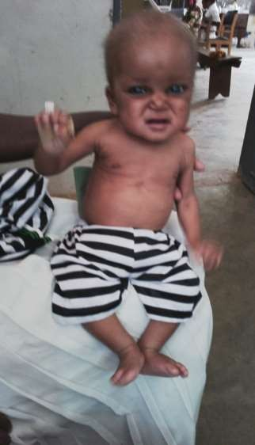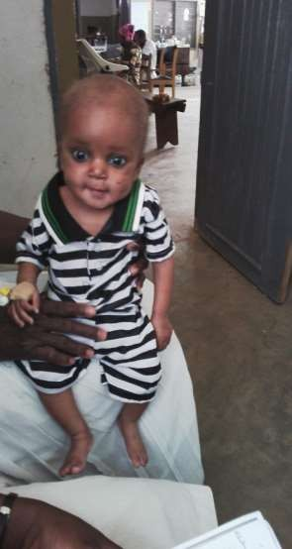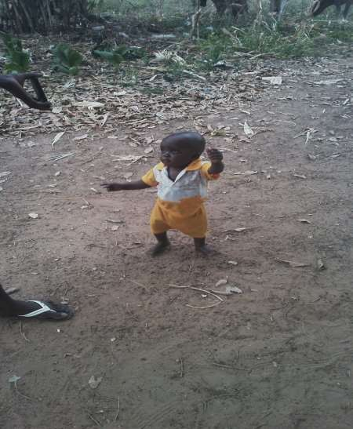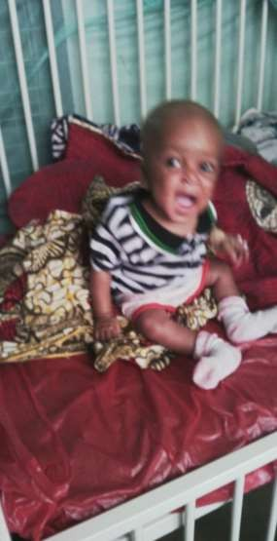Before treatment After treatment

IMPROVING LIVES THROUGH NUTRITION
BEFORE TREATMENT
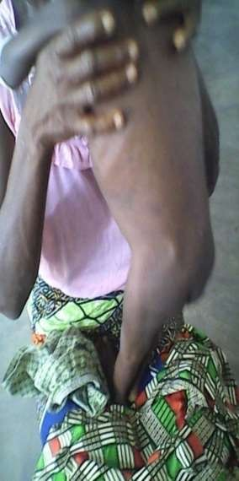
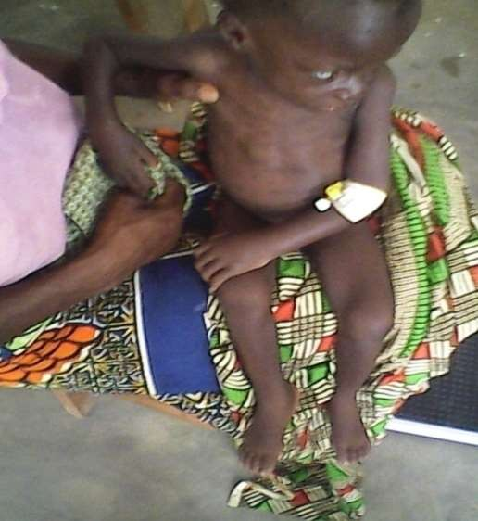
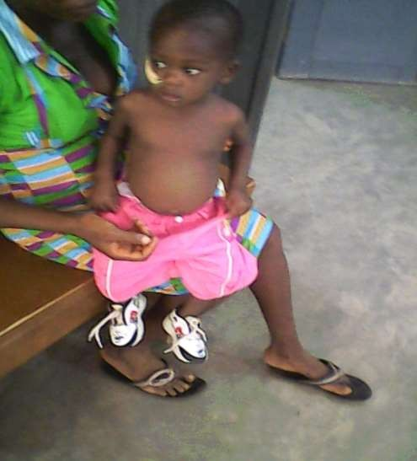AFTER TREATMENT

GIVING HOPE TO THE HOPELESS THROUGH NUTRITION
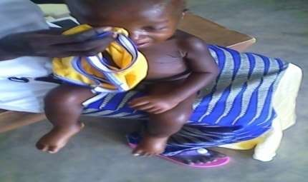
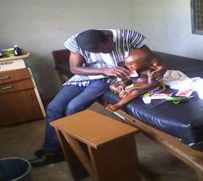
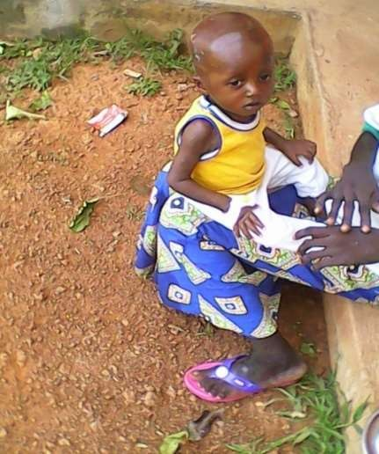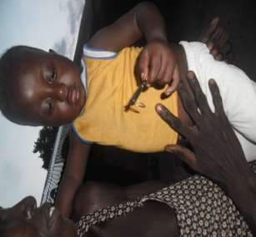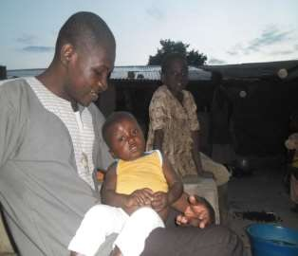BEFORE TREATMENT DURING RECOVERY AFTER TREATMENT

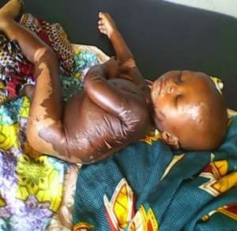
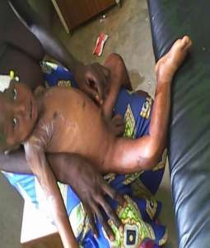

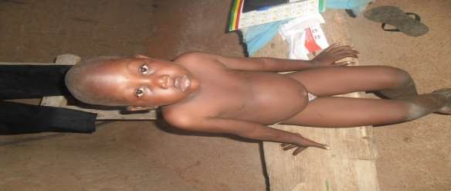
REACHING THE UNREACH IN SOCIETY FOR GOOD FUTURE
FOR THE WORLD.
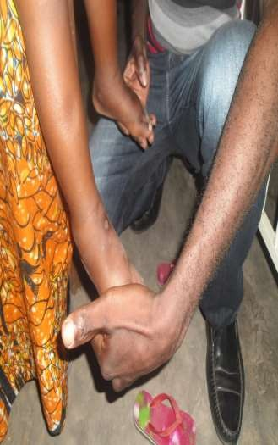
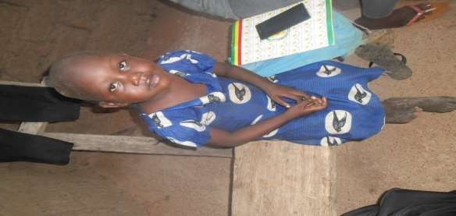
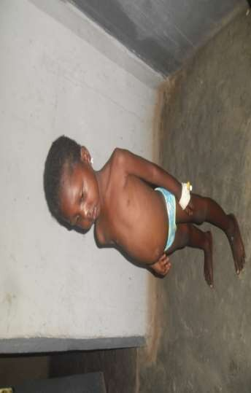
BEFORE TREATMENT AFTER TREATMENT

NUTRITION KEY TO SUSTANABLE DEVELOPMENT GOAL
ATTAINMENT
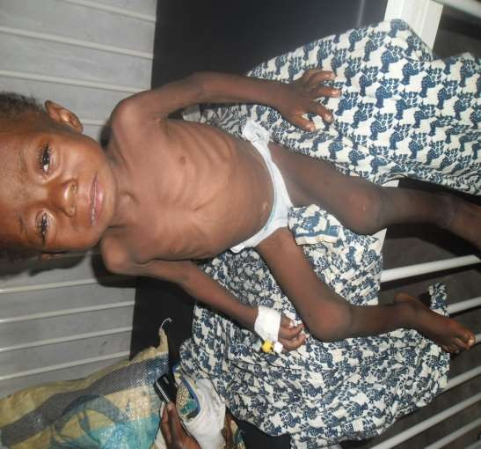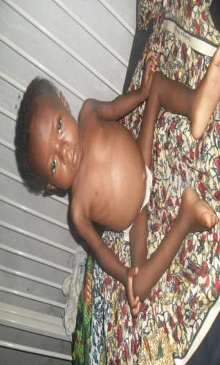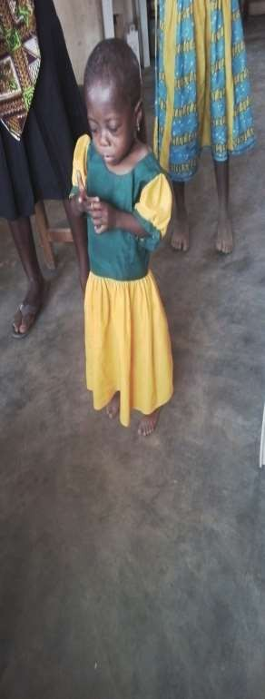BEFORE TREATMENT AFTER TEREATMENT

IMPROVING THE ECONOMY THROUGH NUTRITION
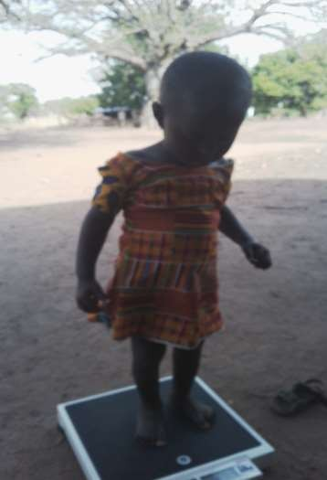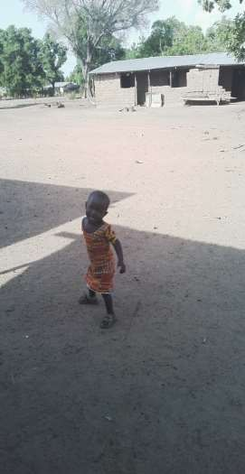BEFORE TREATMENT AFTER TREATMENT
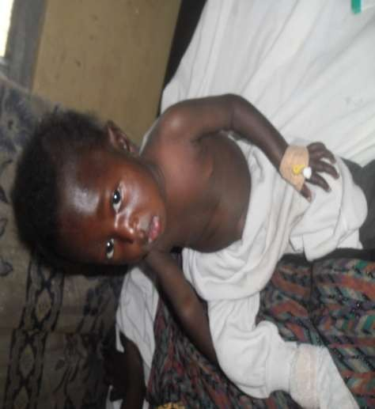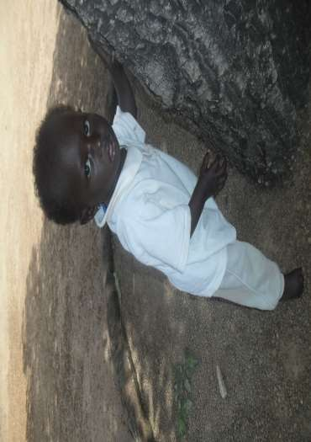

EVERY STAKEHOLDER IS KEY IN MALNUTRITION
MANAGENMurses Ein pNrepaTring feeds and giving emotional and phsychological support

EDWARD KUUBERME NAAPONG leading a malnourished family to social welfare for support (district assembly – NADOWLI-KALEO)
to a malnourished child and care giver together with nutrition officer.
Edward also demonstrate to nurses how to feed and care for malnourished
children in the Nadowli District Hospital.

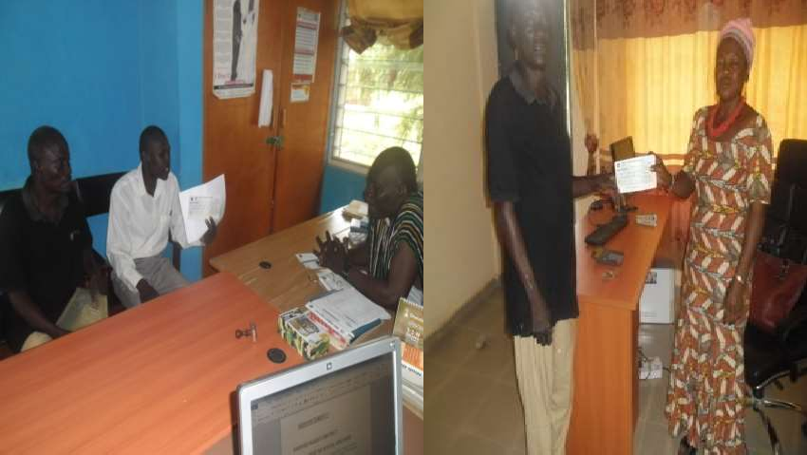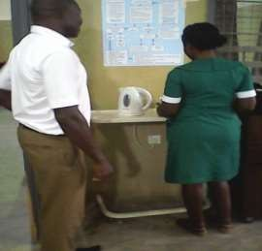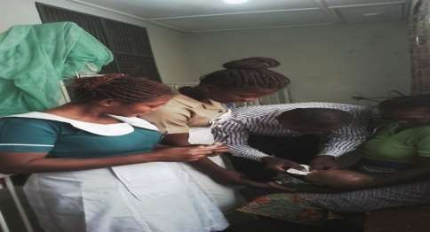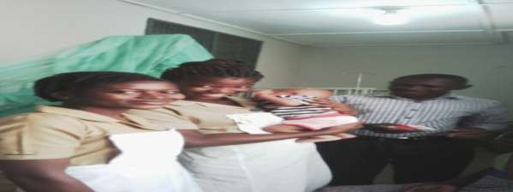

Team work is key to saving lives in Special children
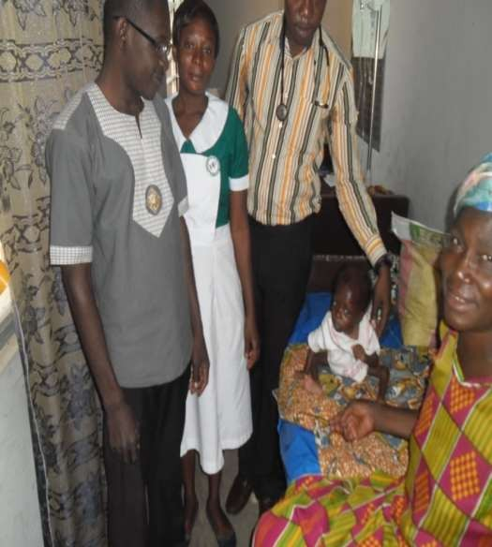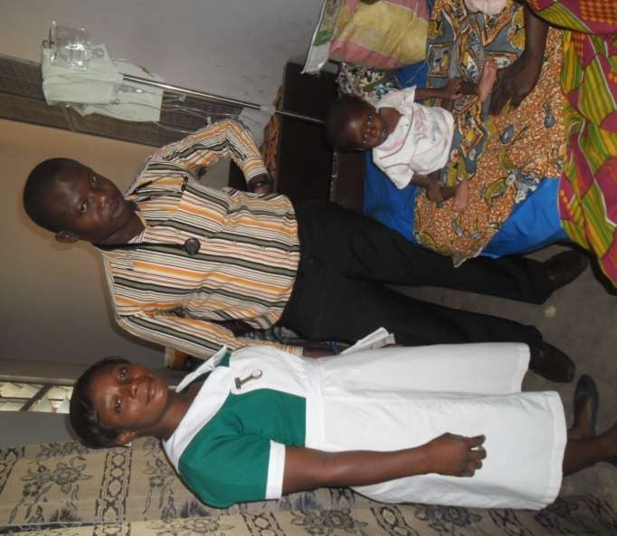

EVERY CHILD IS LIABLE TO MALNUTRITION
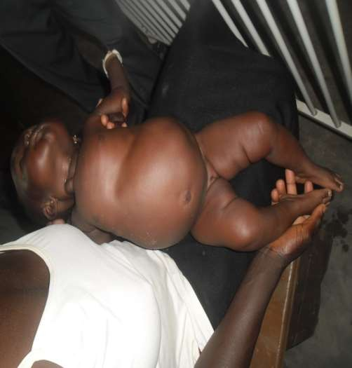
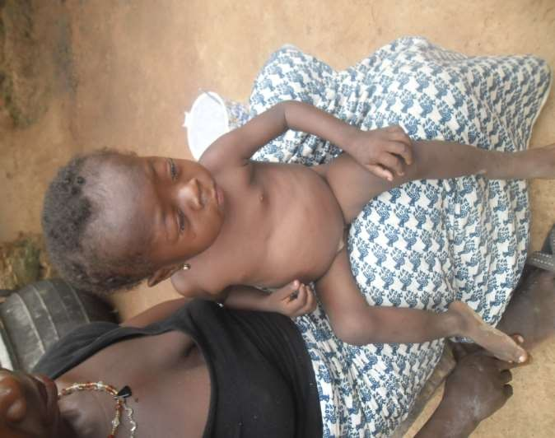A CHILD UNDER 6MONTHS CHILD 6-59(MONTHS)

OUR ROLE AS HEALTH PROFESSIONALS

INVOLVING ALL IN CMAM CARE
EVERYBODY IS INVOLED
Edward organized severe acute malnutrition training for staff .
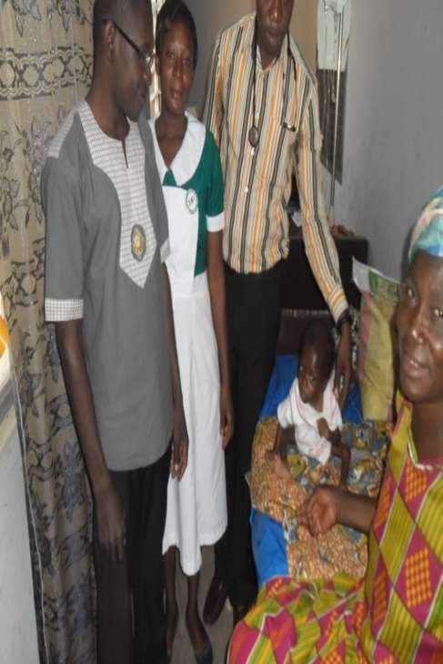
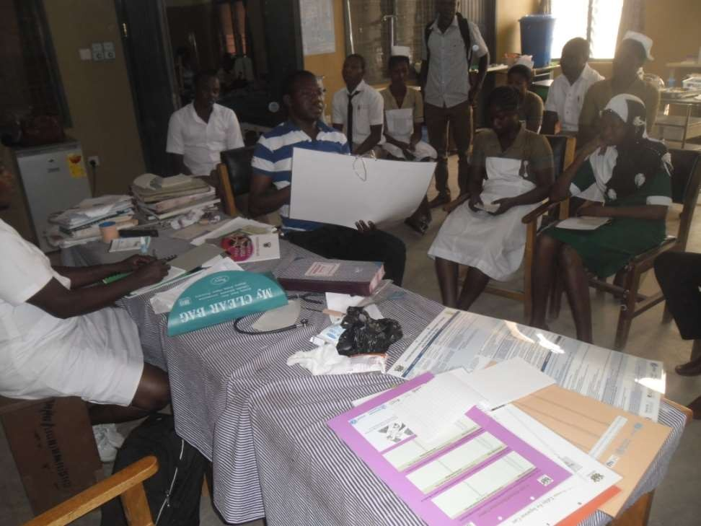

REARING FOR LIFE PROJECT:Family received livestock to ensure food security,
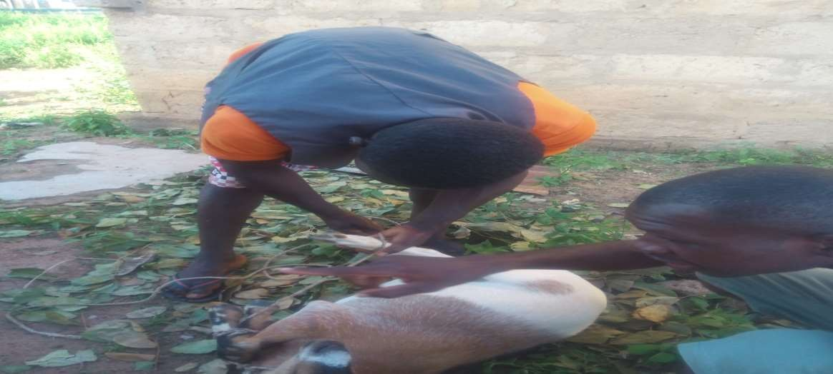
nutrition, health and wellbeing from Edward Kuuberme Naapong.

Nutrition Assessment, Counseling, and Support for
Children living HIV/AIDS/TB
BEFORE TREATMENT AFTER TREATMENT
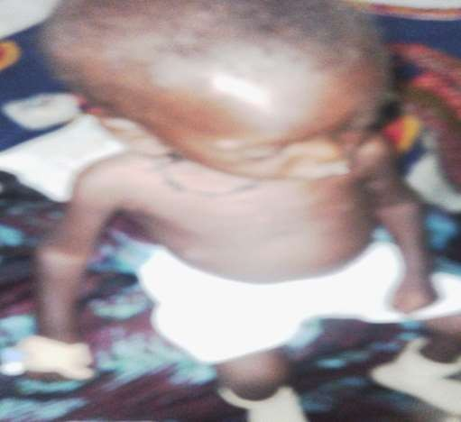
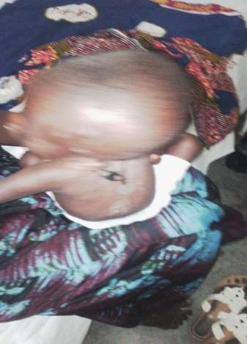
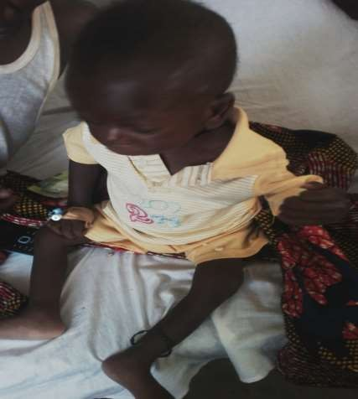

IMPROVING AND PROLONGING LIVES OF HIV/AIDS CHILDREN WITH ADEQUATE NUTRITION SUPPORT.

After treatment

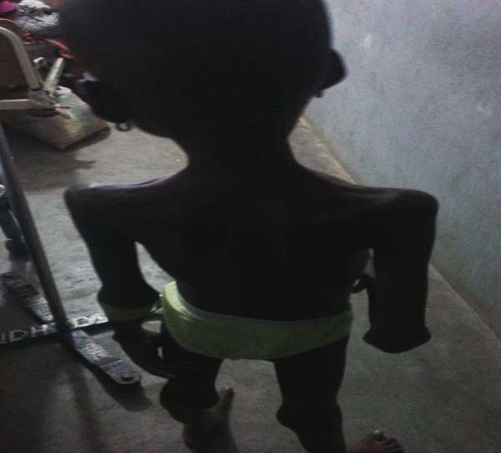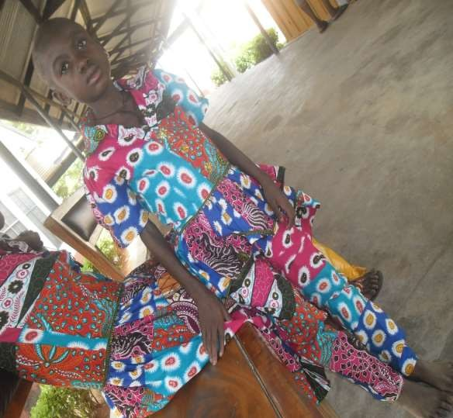

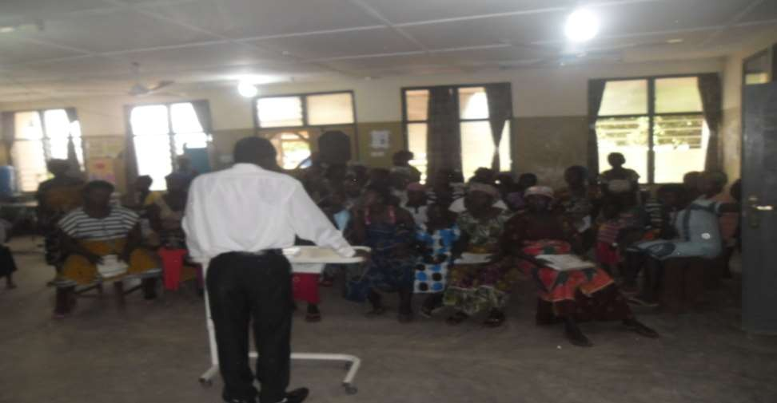
Building the capacity of family members on child’s nutrition.

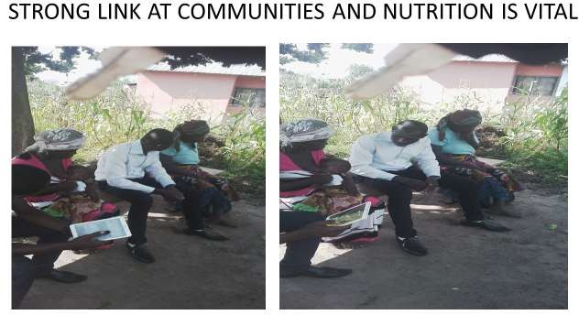

Visiting clients at home is paramount to changing
lives of vulnerable and getting the root cause.

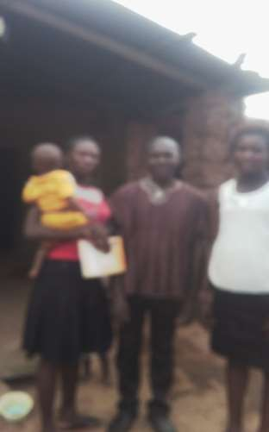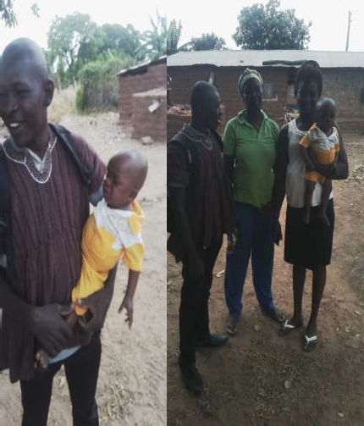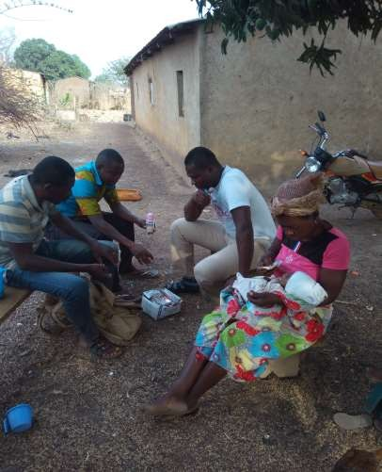

More information is gotten during home visit
Getting to the root is more important Engaging family during home visit
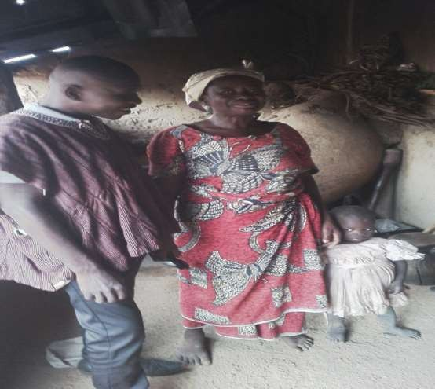
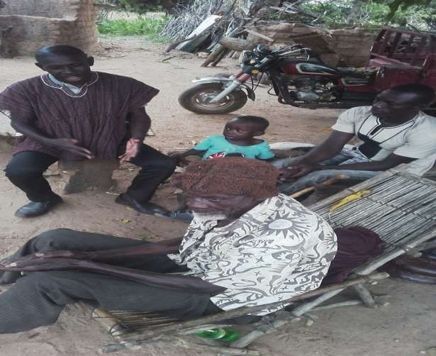

Underprivileged communities don’t need much to be happy.
Clean water gives happiness.

Engagement with a section of Baalayir community members
on ways to resolving their water crisis in 2017
EVRYONE CAN DO MORE WITH THE LITTLE IN COMMUNITIES
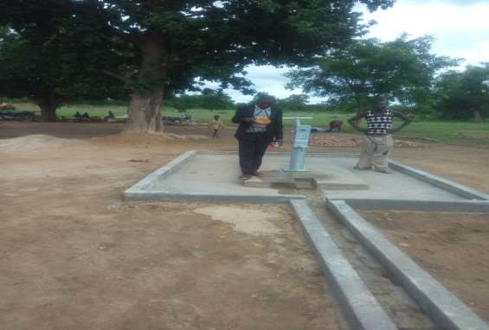
FOR POSITIVE CHANGE

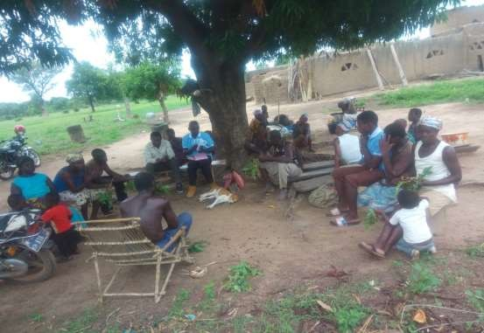

Access to Water Improve Nutrition, health and wellbeing
all Time in the Year and Conquer Poverty.
DRY SEASON VEGETABLE GARDEN IN
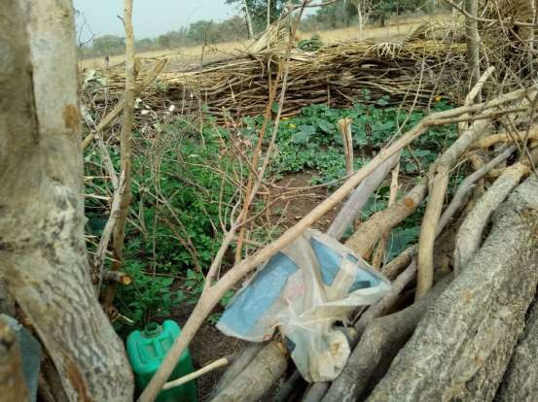
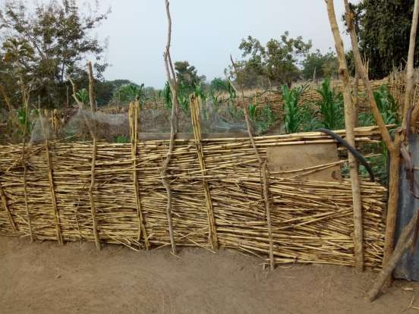
BAALAYIR. DRY SEASON MAIZE FARM IN BAALAYIR.

With Nutrition and Health, there is a sustained individual potential and economic growth beyond expectations.

